|  |
| --- |
| University of Calgary |
| ENEL 476 |
| Laboratory #3 – Smith Chart / Tuning |
|  |
| **Kyle Derby MacInnis**  **Callum _________**  **_______________** |
| **3/13/2013** |

|  |
| --- |
| The purpose of this lab is to explore and understand the use of Smith Charts and how they can be used in solving common problems in EM wave applications such as tuning a circuit such that it has an effectively matched load. |

**Prelab Exercises:** **\* Please Refer to Appendix A for Smith Charts**

**Question #1:** Given a lossless transmission line with terminated by an unmatched load of , the following results were obtained (See Smith Chart #1):

Since the Smith Chart we are using is normalized, we must normalize our load:

After plotting our load on the Smith chart and measuring all required lengths the following Reflection Coefficient was obtained:

In order to compare this answer we will calculate it separately:

This value is in accordance with the value ascertained via the Smith Chart. For ease of use, the value from the Smith Chart will be used unless otherwise mentioned.

**Question #2:** Using the above mentioned transmission line and load, determine the length and position required for 4 shunt tuners (2 Open-circuited, 2 Close-circuited) which will help to match the load for this transmission line. The following locations and Lengths were determined with the use of the included Smith Charts:

In order to calculate the required lengths of the stubs and their positions we will use the Smith Chart as an Admittance Chart (see Smith Chart #2):

Short Circuited Stubs: (@ 5 GHz - )

|  |  |  |
| --- | --- | --- |
| **Stub** | **Length (WTG/mm)** | **Position (WTG/mm)** |
| Stub #1 | 0.09 / 5.50 | 0.47 / 28.2 |
| Stub #2 | 0.41 / 24.6 | 0.11 / 6.60 |

Table - Shorted Stub Configurations

Open Circuited Stubs: (@ 5 GHz - )

|  |  |  |
| --- | --- | --- |
| **Stub** | **Length (WTG/mm)** | **Position (WTG/mm)** |
| Stub #1 | 0.34 / 20.4 | 0.47 / 28.2 |
| Stub #2 | 0.16 / 9.60 | 0.11 / 6.60 |

Table - Open Stub Configurations

**Laboratory Observations:**

In this laboratory the software suite MEFiSTo-2D is used to run all simulations. The procedure used to setup the simulation environment is listed in the lab manual for this experiment and no deviations were made.

Each individual stub was simulated separately and the following waveform observations were made as per the manual:

Short Circuited Stubs:

**Stub #1 (Located: 28.2mm from load; Length: 5.5mm):**

1. **Stub**: The waveform which is generated within the stub shows what appears to be a standing wave which is located with a maximum at the end of the stub’s short. There does not seem to be any majorly noticeable travelling wave present in the stub.
2. **Stub-Load Junction**: The waveform which is generated between the stub and the load appears to be a pure standing wave with little to no travelling component present.
3. **Transmission Line**: The waveform generated within the rest of the transmission line is a partially travelling wave with minor standing wave response.
4. **Reflection Coefficient**: The observed value for this configuration was:

**Stub #2 (Located: 6.6mm from load; Length: 24.6mm):**

1. **Stub:** The waveform observed within the stub for this configuration appears to be an almost pure travelling wave. Little to no standing wave response is observed to be present.
2. **Stub-Load Junction:** The waveform between the stub and the load for this configuration was observed to be a standing wave with little travelling wave response present.
3. **Transmission Line:** The waveform generated within the transmission line up to the load was observed to be a partially travelling wave. There was minor standing wave action within the waveform and this was found to be more so than the previous short-circuited stub.
4. **Reflection Coefficient**: The observed value for this configuration was:

Open Circuited Stubs:

**Stub #1 (Located: 28.2mm from load; Length: 20.4mm):**

1. **Stub:** The waveform generated and observed within the stub was seen to be a full standing wave. There was almost no travelling wave present and in addition the waveform was amplified in regards to the initial wave.
2. **Stub Load Junction:** The waveform observed between the stub and the load was observed and deemed an almost pure standing wave. The waveform was also amplified in regards to the initial wave.
3. **Transmission Line:** The waveform which was observed within the transmission line was an almost pure travelling wave. There was very little standing wave response within the generated form with almost no reflection interference.
4. **Reflection Coefficient**: The observed value for this configuration was:

**Stub #2 (Located: 6.6mm from load; Length: 9.6mm):**

1. **Stub:** The waveform generated within the stub was observed to be a partially standing wave with almost no travelling component present with the wave.
2. **Stub-Load Junction:** The waveform observed between the stub and the load for this setup was seen to be an almost pure standing wave with large attenuation. The waveform was attenuated approximately to half that of the initial waveform.
3. **Transmission Line:** The waveform which was observed along the rest of the transmission line leading up to the load was seen to be a partially travelling wave. There was minor standing wave action along the waveform.
4. **Reflection Coefficient**: The observed value for this configuration was:

Additional Observations:

In each situation, none of the configurations resulted in a pure travelling wave being generated within the transmission line, and resulted with the open circuited stubs being more effective overall. The short circuited stubs were less effective in general albeit stub #1 was the second most effective in the experiment. Most of the cases showed some attenuation and/or amplification to either the stub or the stub-load junction waveforms, but unless previously mentioned did not appear to be significant to the results or was hardly noticeable.

When the frequency was changed to different values (4.5 GHz & 5.5 GHz) there was noticeable change to the waveform response. For the Short-Circuited Stub #1 there was an increase in the Standing Wave response with 5.5 GHz, and there was a slightly attenuated response with 4.5 GHz.

Movement of the stubs did vary the response, but as to any conclusions it was difficult to come to a consensus as the precision of the environment was less than one would have desired

**Calculations:**

The following is a sample calculation for SWR using the reflection coefficient of the original load configuration:

The calculated SWR values for the stub configurations are shown in the table below:

|  |  |  |  |
| --- | --- | --- | --- |
| **Short-Circuited Stubs** | | **Open-Circuited Stubs** | |
| *Stub #1* | *Stub #2* | *Stub #1* | *Stub #2* |
| 2.51 | 2.92 | 1.25 | 2.57 |

Table - Calculated SWR for Stub Configurations

**Conclusion:**

<Enter Conclusion>

**Appendix A: Smith Charts**

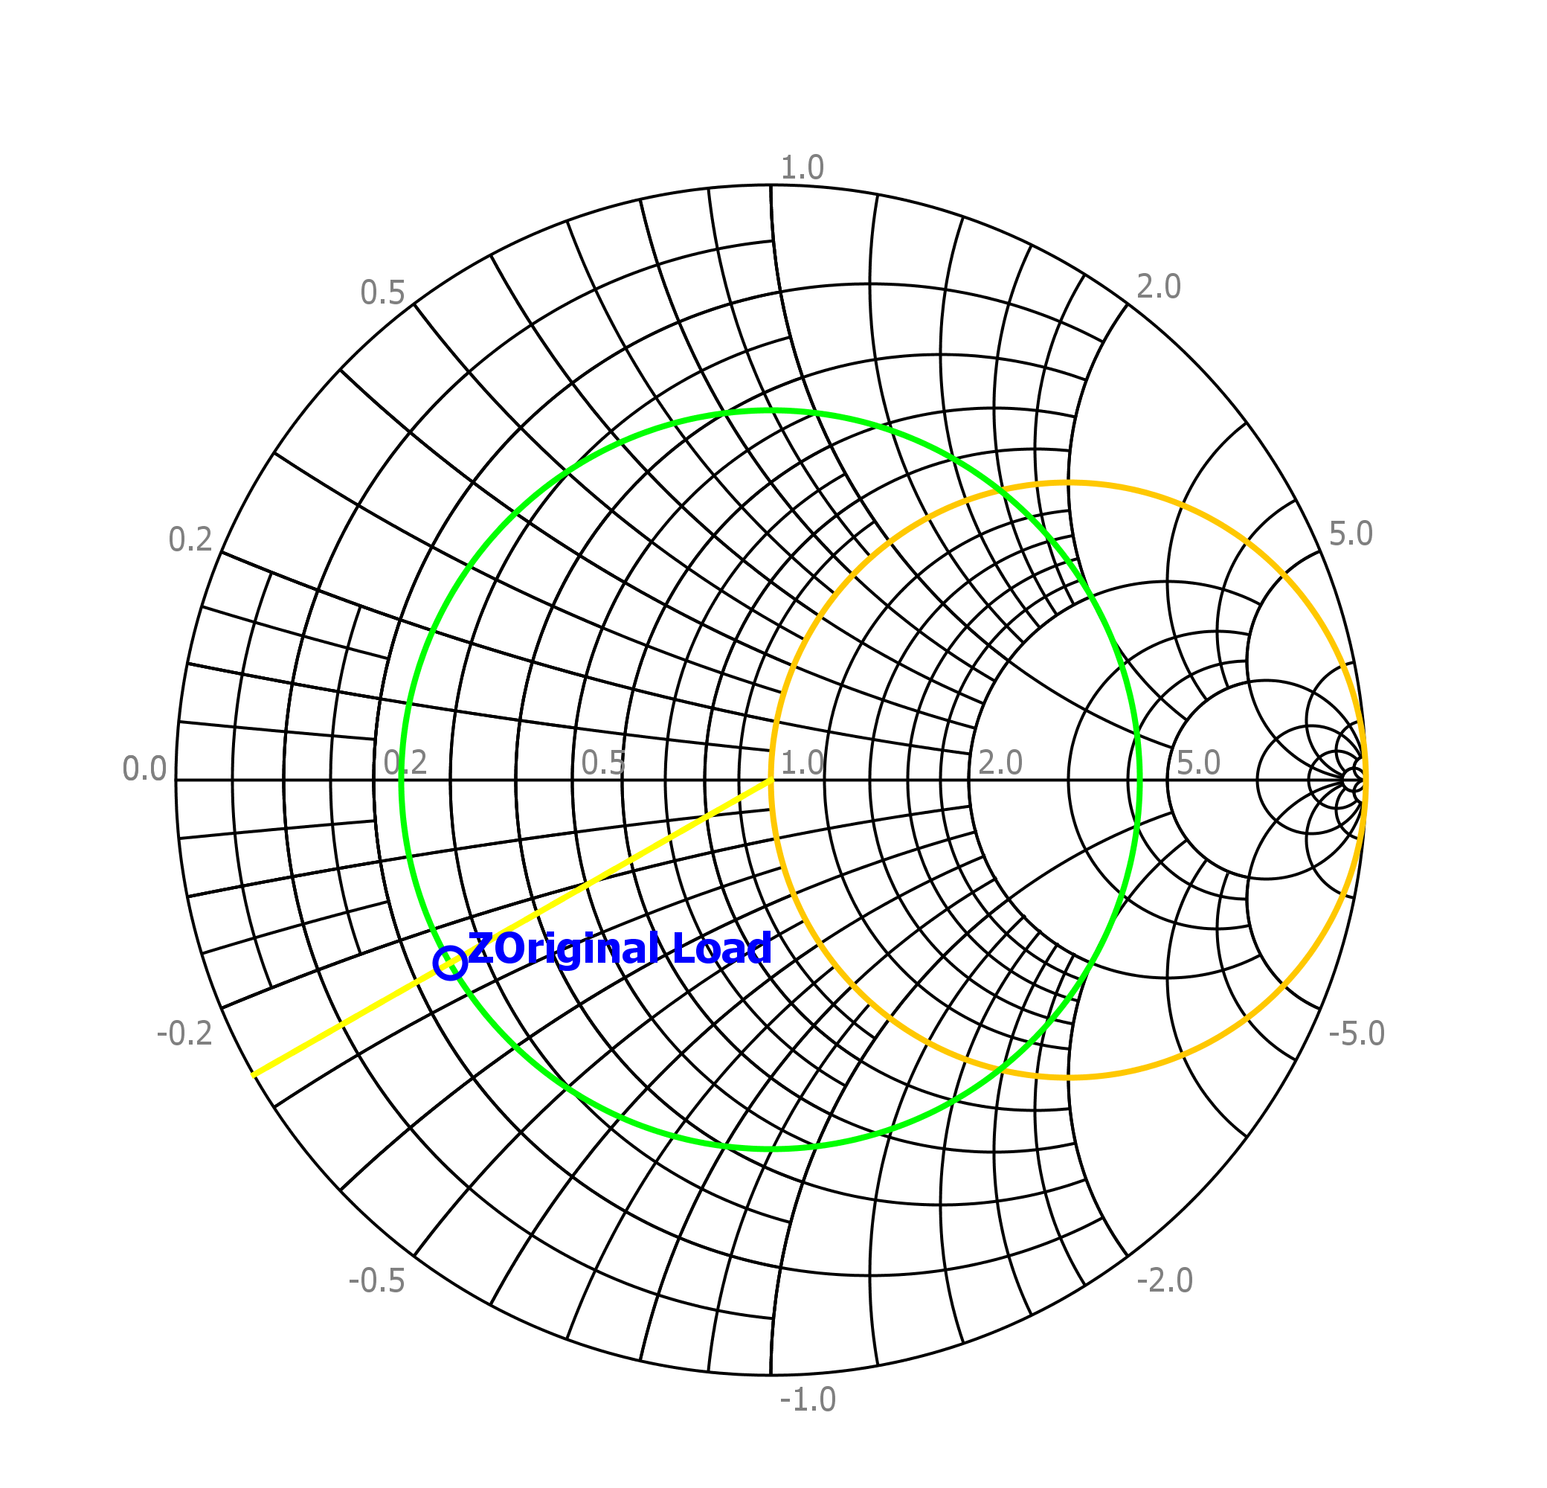

Smith Chart - Impedance Chart

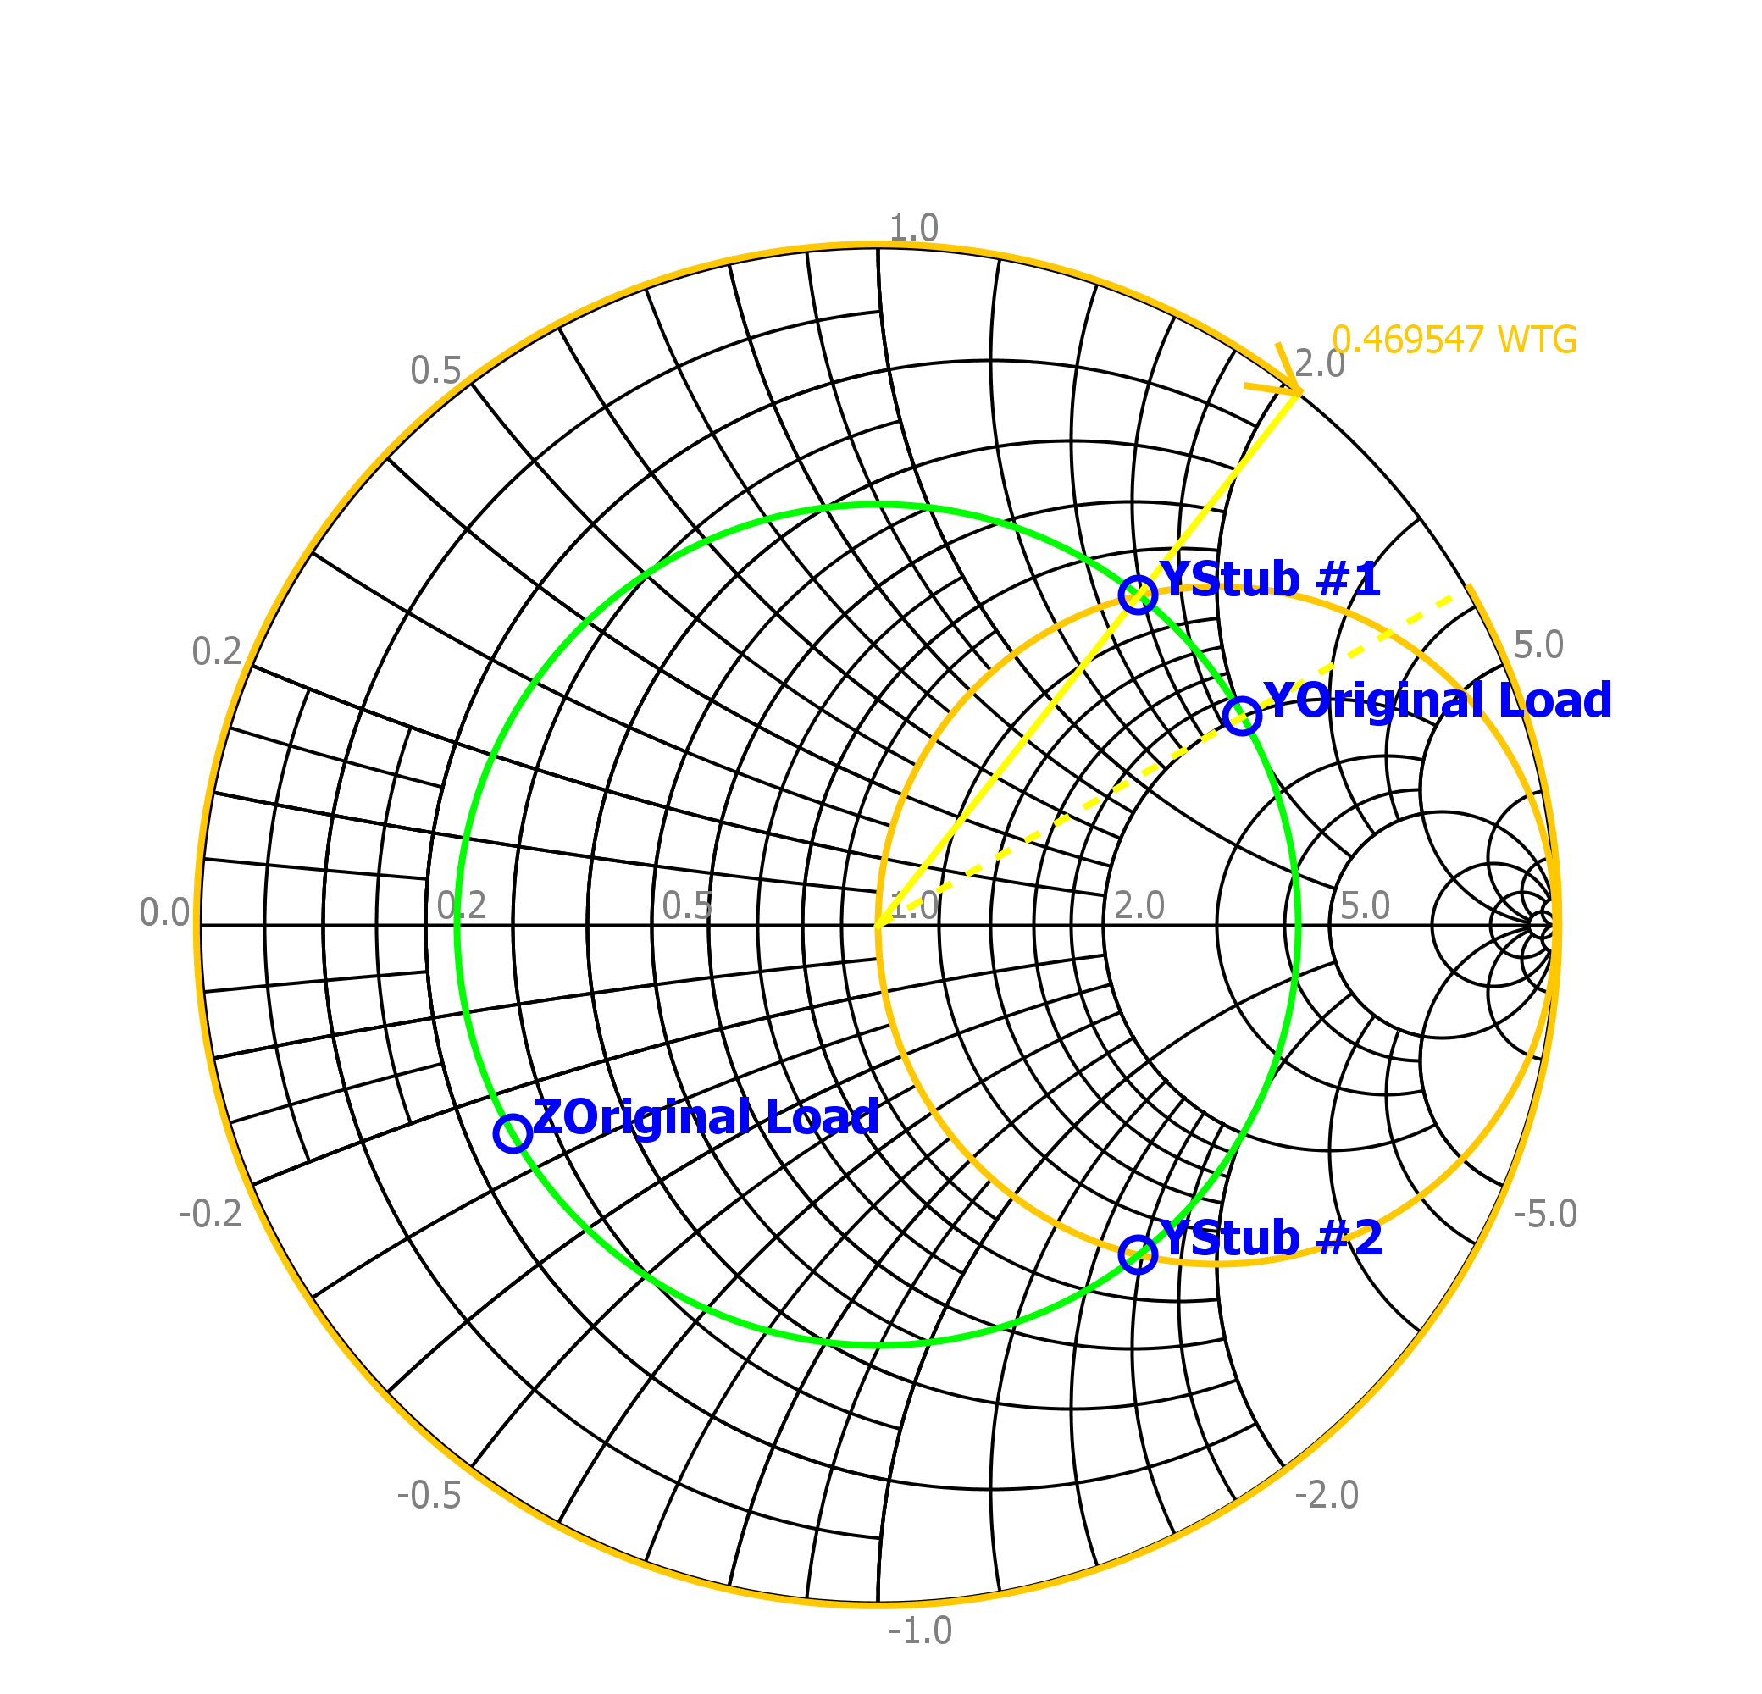

Smith Chart - Stub #1 Location (WTG)

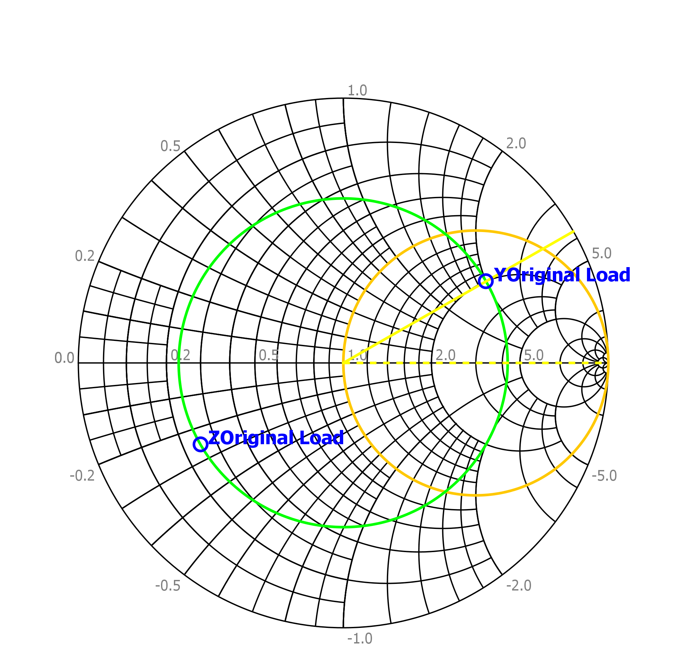

Smith Chart – Admittance Chart

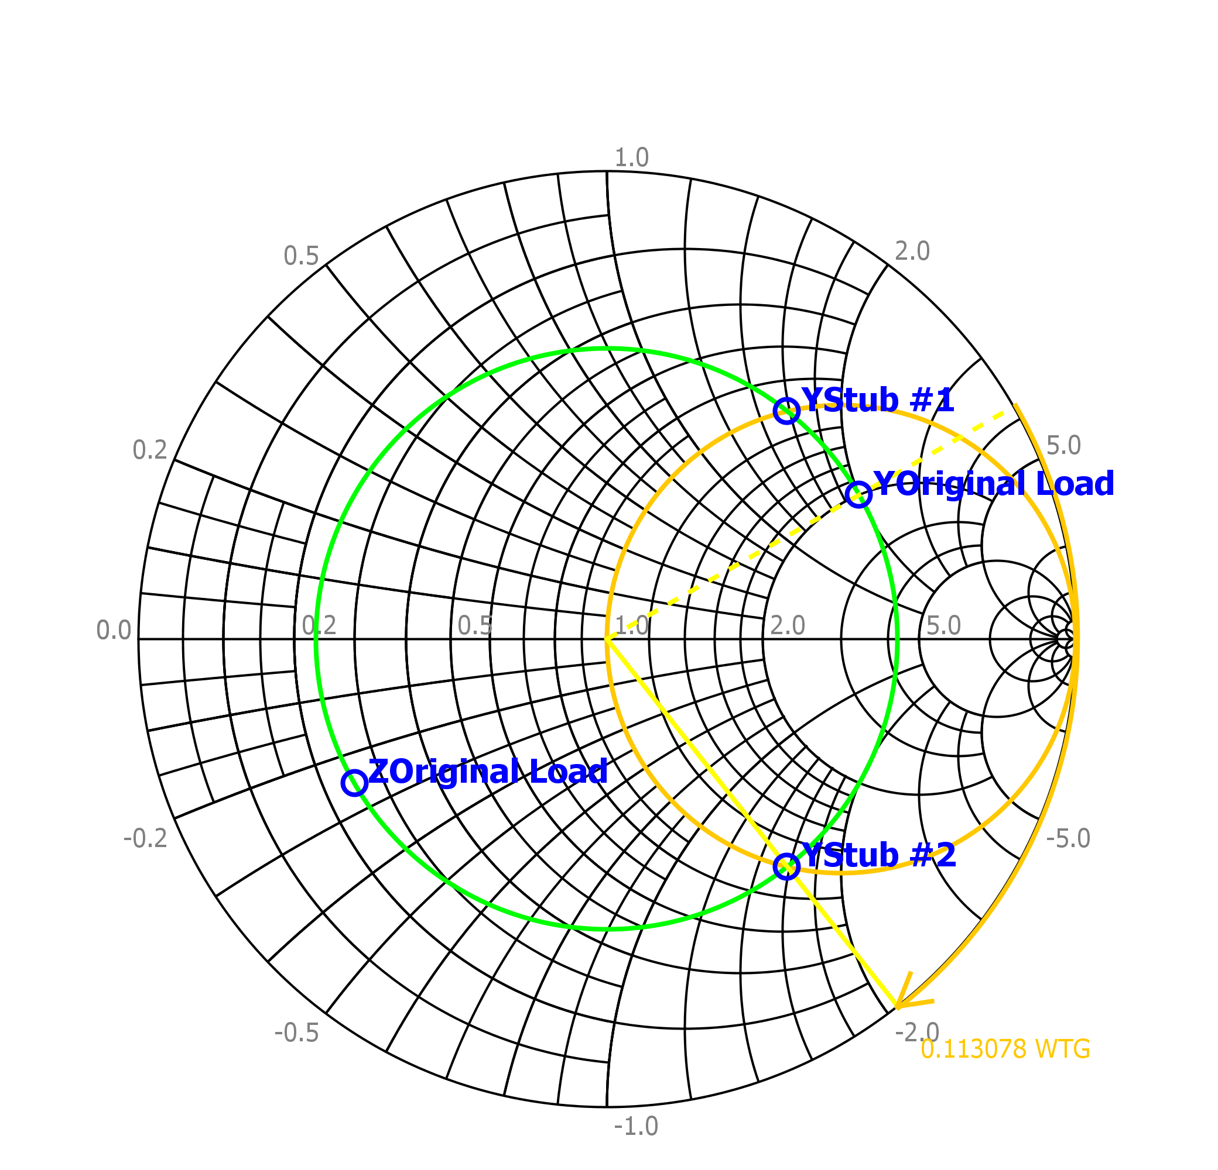

Smith Chart - Stub #2 Location (WTG)

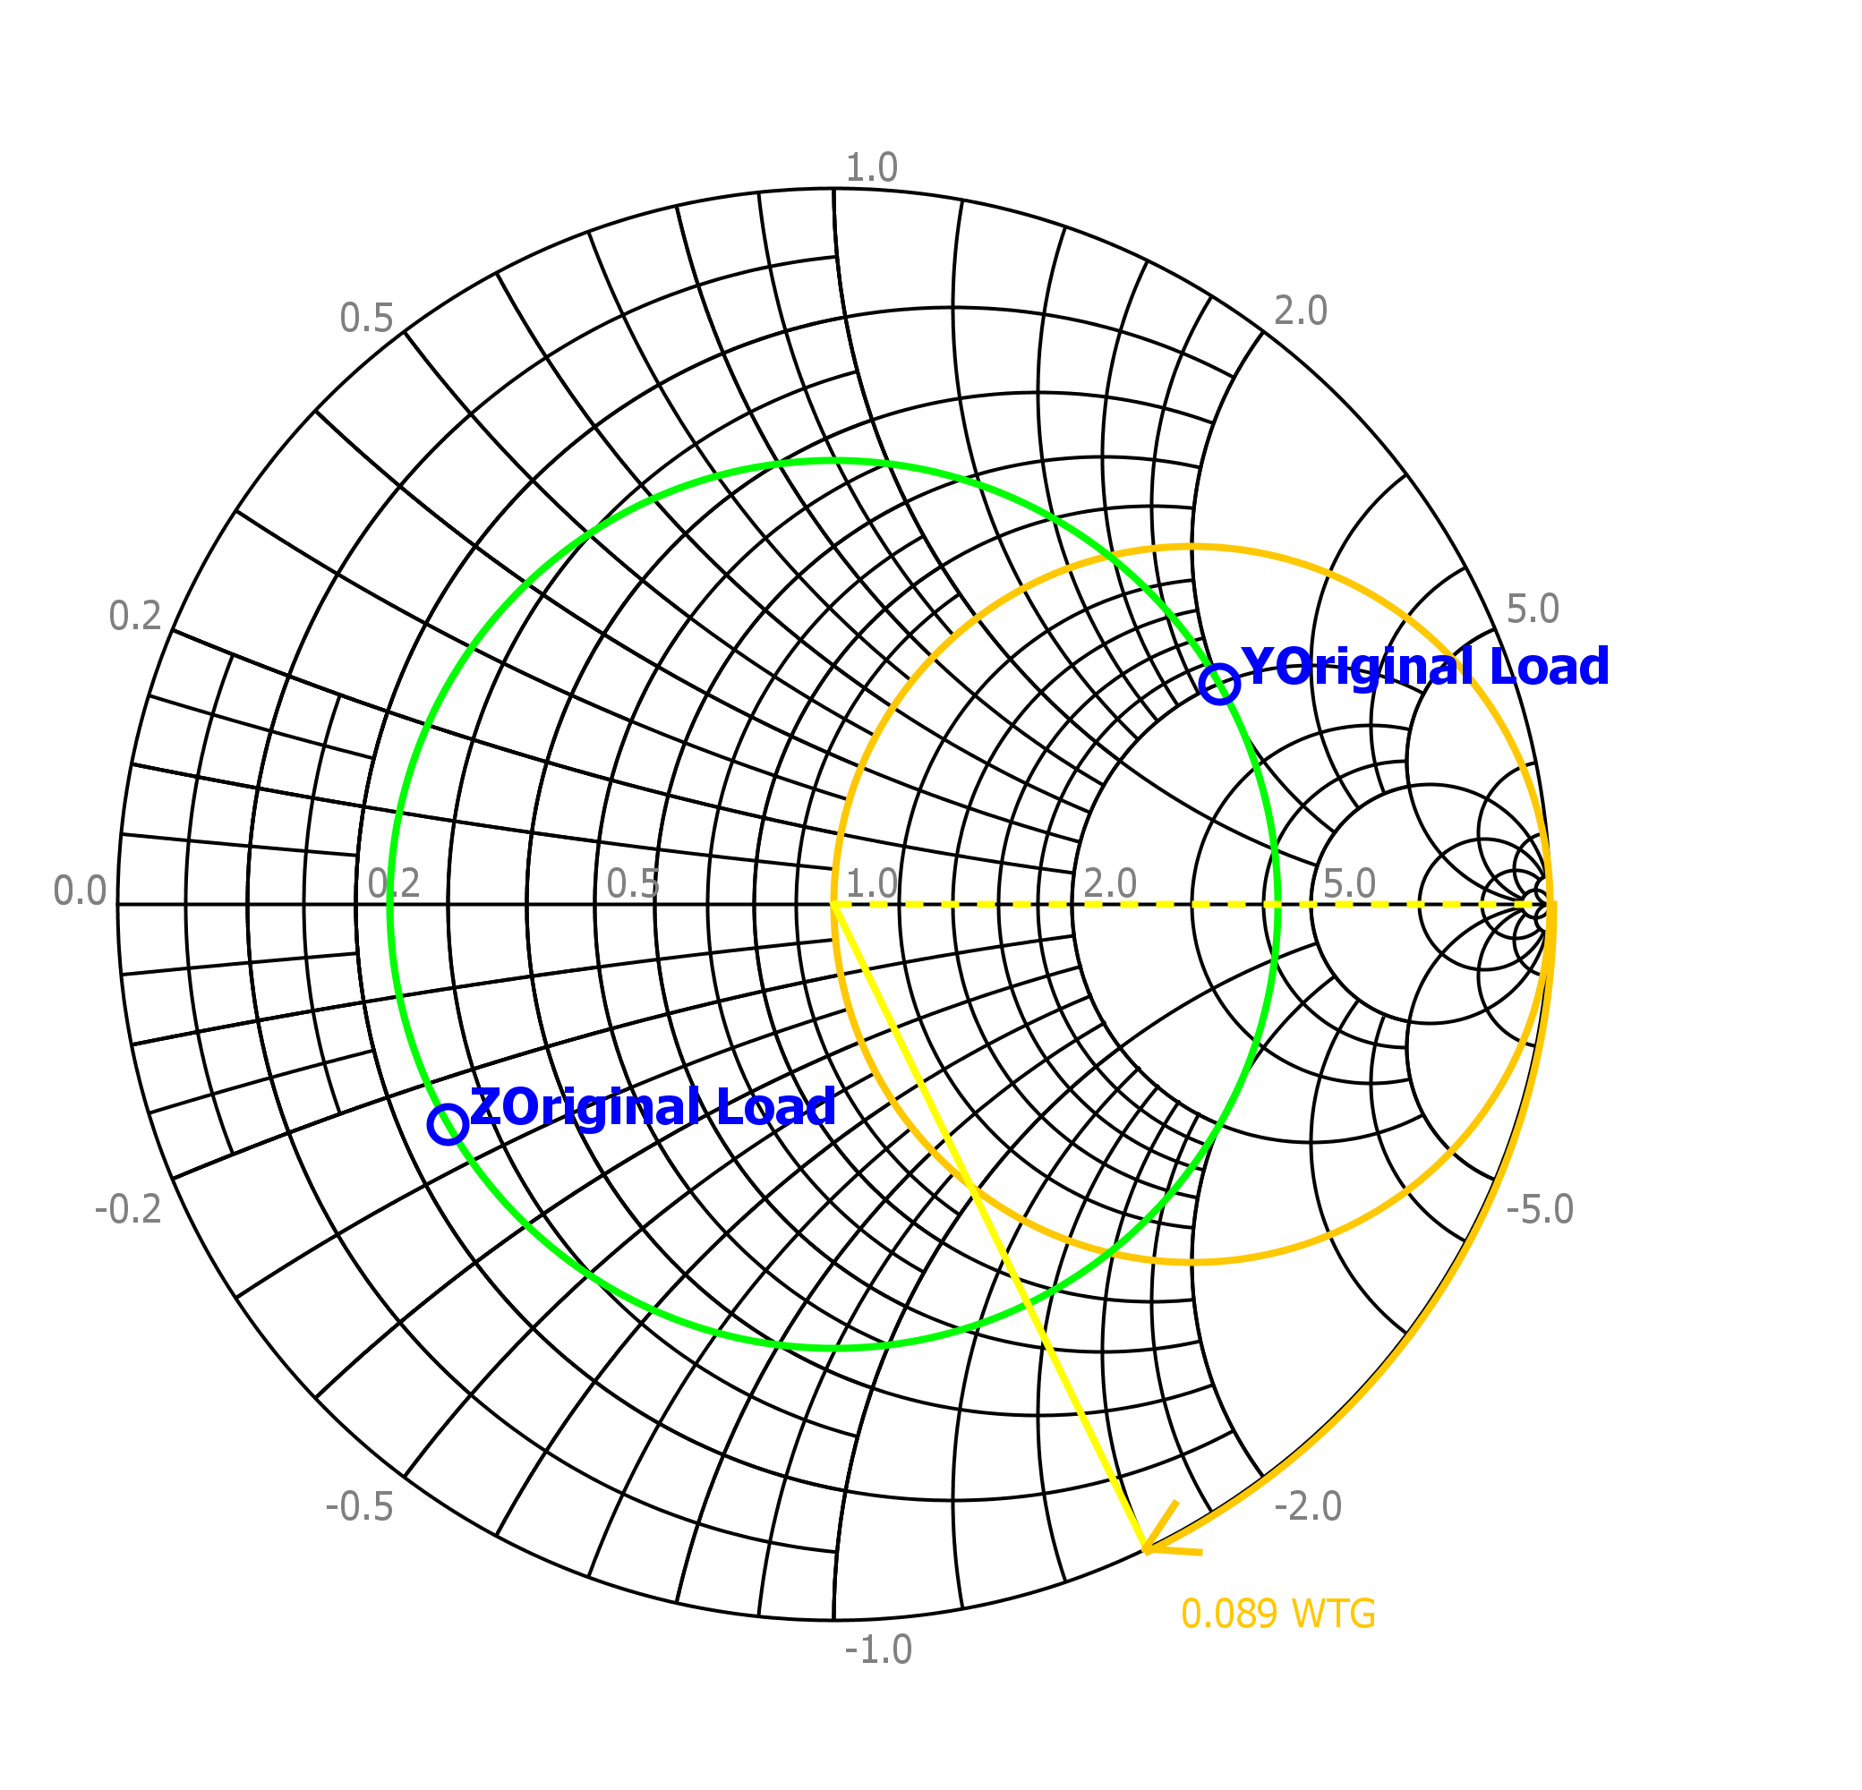

Smith Chart - Length for Shorted Stub #1

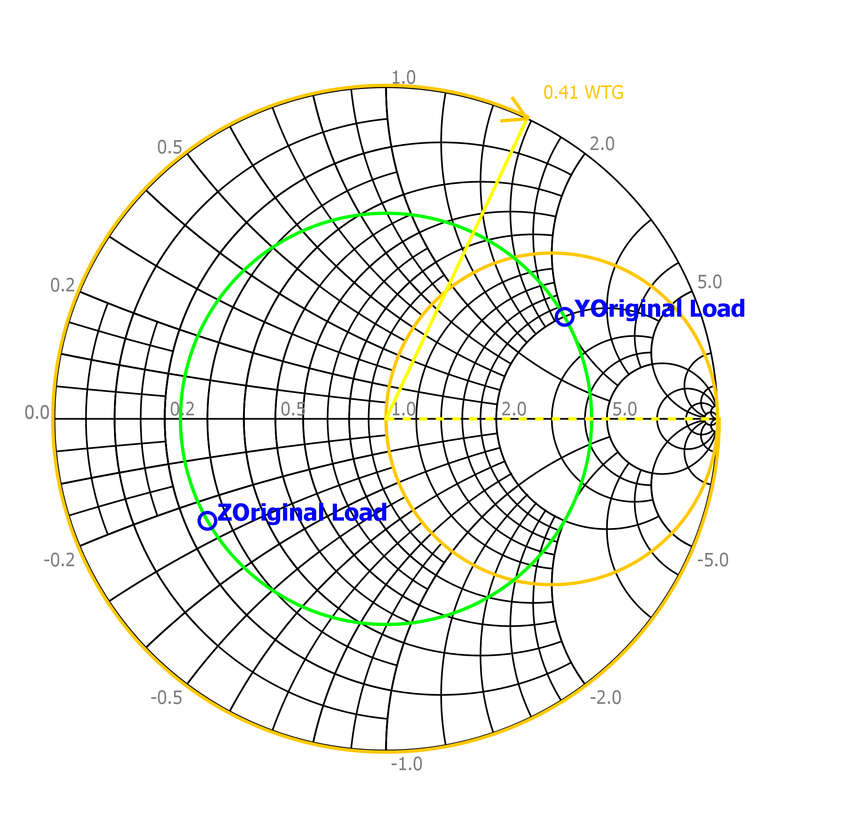

Smith Chart - Length for Shorted Stub #2

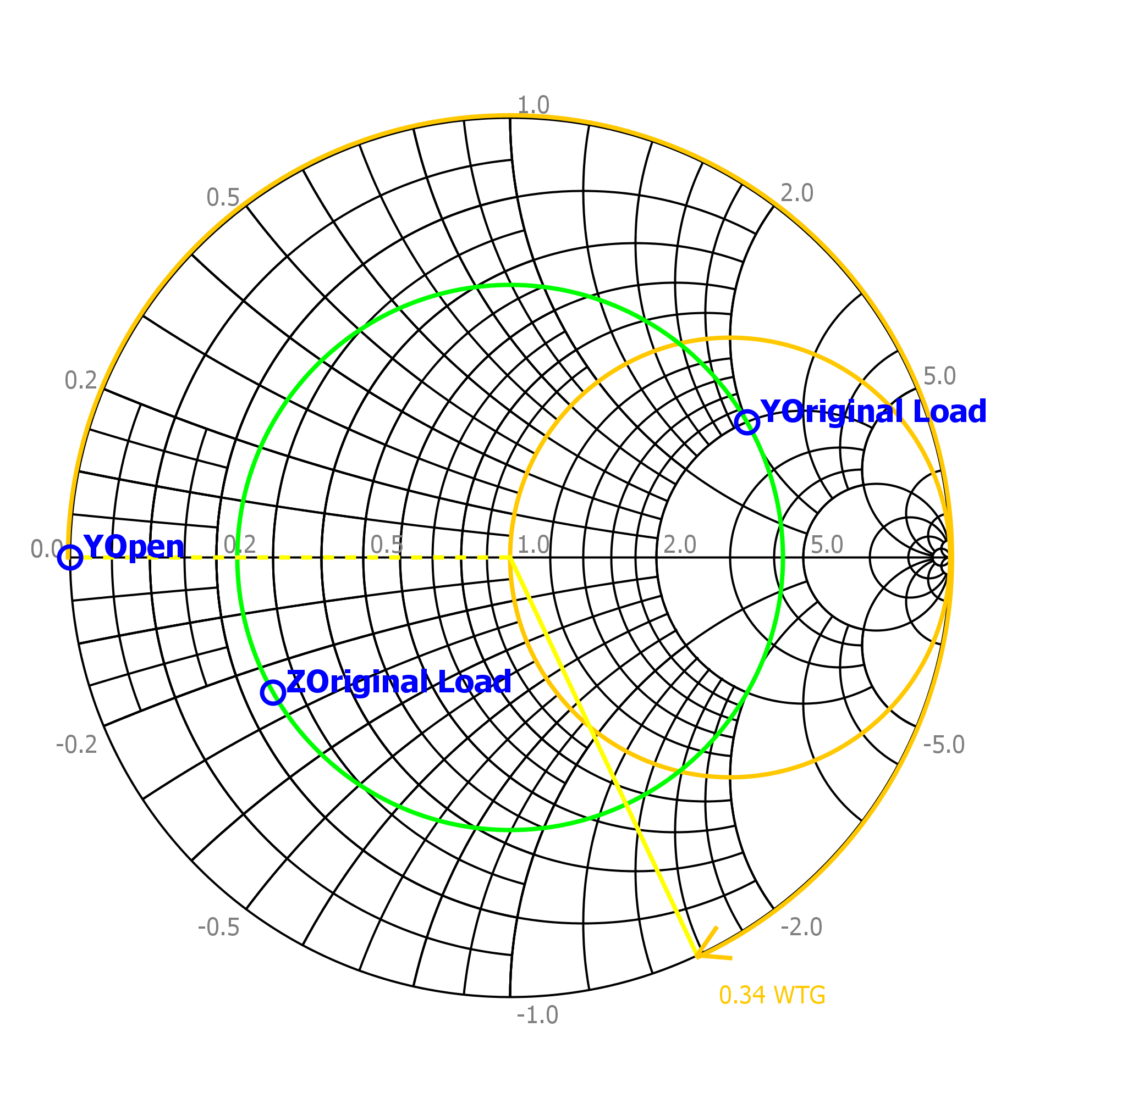

Smith Chart - Length of Open Stub #1

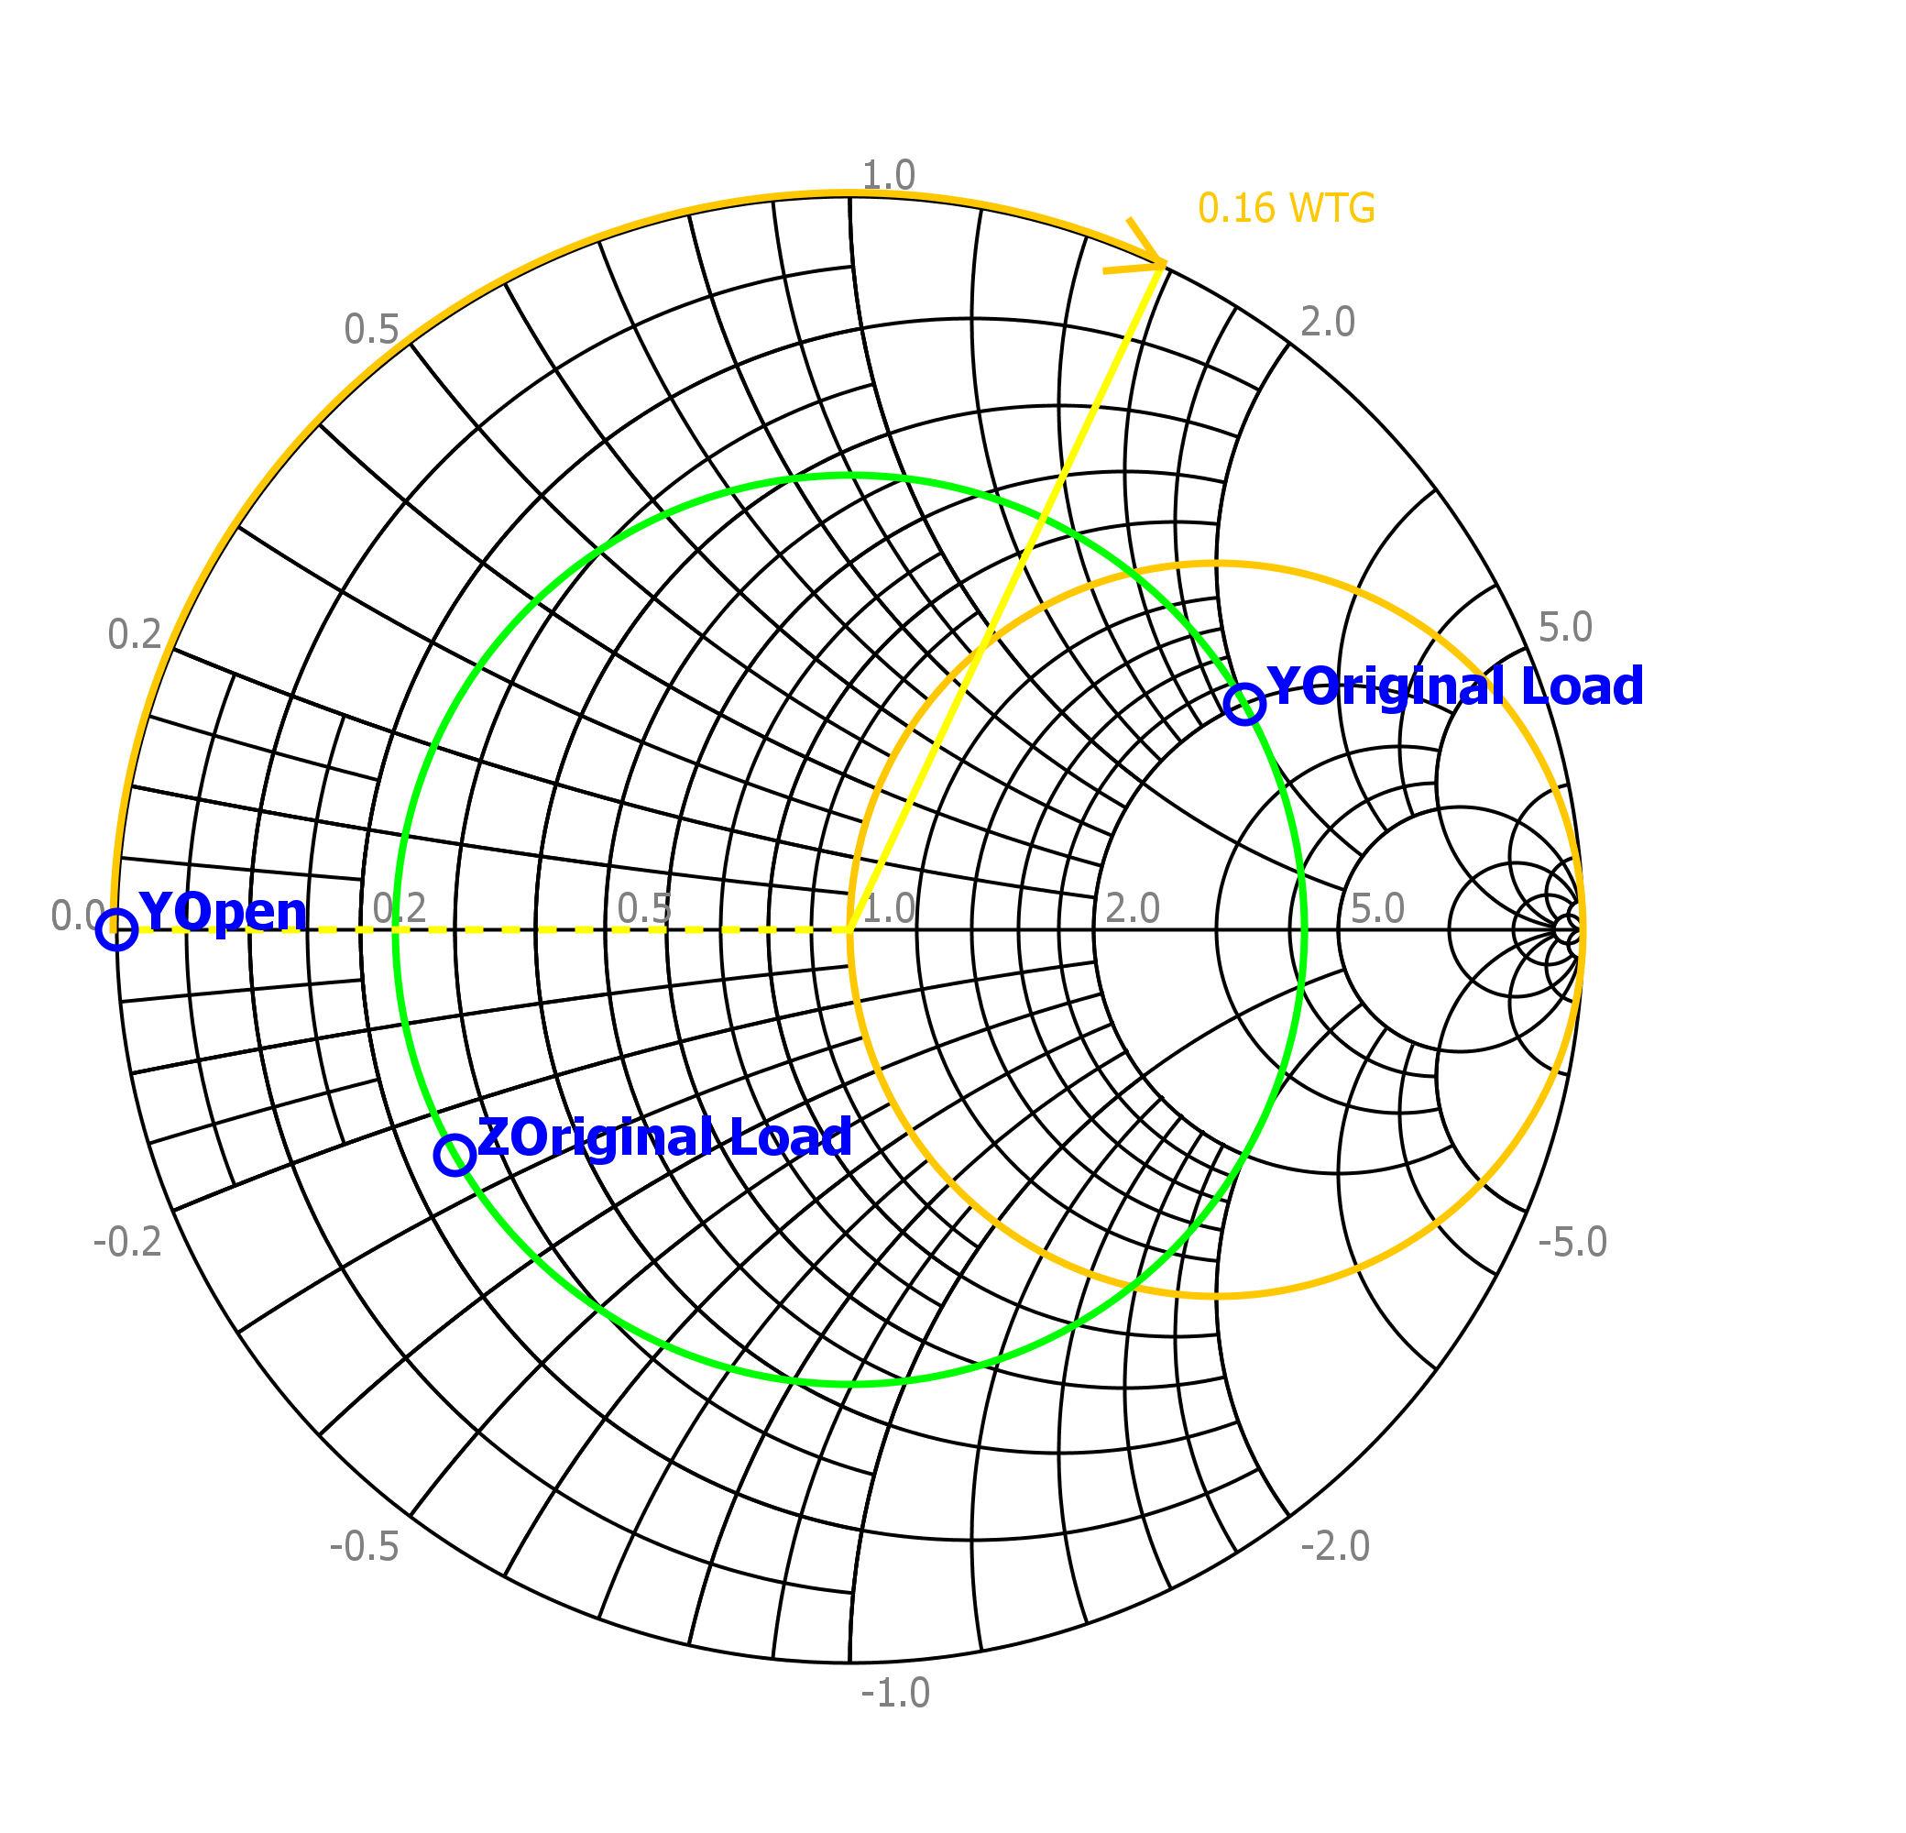

Smith Chart - Length of Open Stub #2